EXHIBIT 5.4
Reply Device, San Francisco Conservatory of Music
- BRAVO!
- I accept your invitation to become a Friend of the San Francisco Conservatory of Music.
I want to help continue the long, proud tradition of music excellence in San Francisco.
Enclosed is my membership gift of:
- $ 40 Regular Membership
$ 100 Special Friend of the Conservatory
$ ___
- Send me my FREE ticket (s) to the Faculty Trio Concert on November 15.
Request must be received by November 8. one ticket two tickets
- 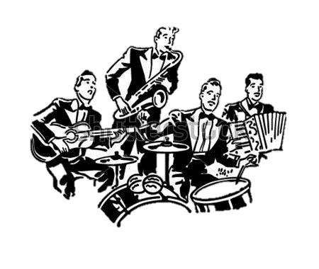
San Francisco Conservatory of Music
1201 ORTEGA ST., SAN FRANISCO, CA 94122
415/759-3463
- Your contribution to the San Francisco Conservatory of Music is fully tax-deductible. Thank you very much.
- Mr. John Doe
123 Any Street
Any Town, AS 00000
- Δ DETACH HERE
- Your Membership Entitles You to Receive:

- 1. A subscription to At the Conservatory, the Conservatory’s monthly newsletter and calendar of events.
2. A special new Member Fall Concert.
3. Membership discounts for Conservatory concerts throughout the year- and for Conservatory extension classes.

4. Advance ticket purchase for Sing-It-Yourself Messiah Concerts at Davies Symphony Hall.
5. Free attendance at the “Friends Only” Tour and Concert (January 1994).
- Please detach top portion, fold and return with your check in the enclosed postage-paid envelope. Keep bottom portion for your records.

